Open Internet Explorer Browser. Type http://printers/
Select your current location/office.
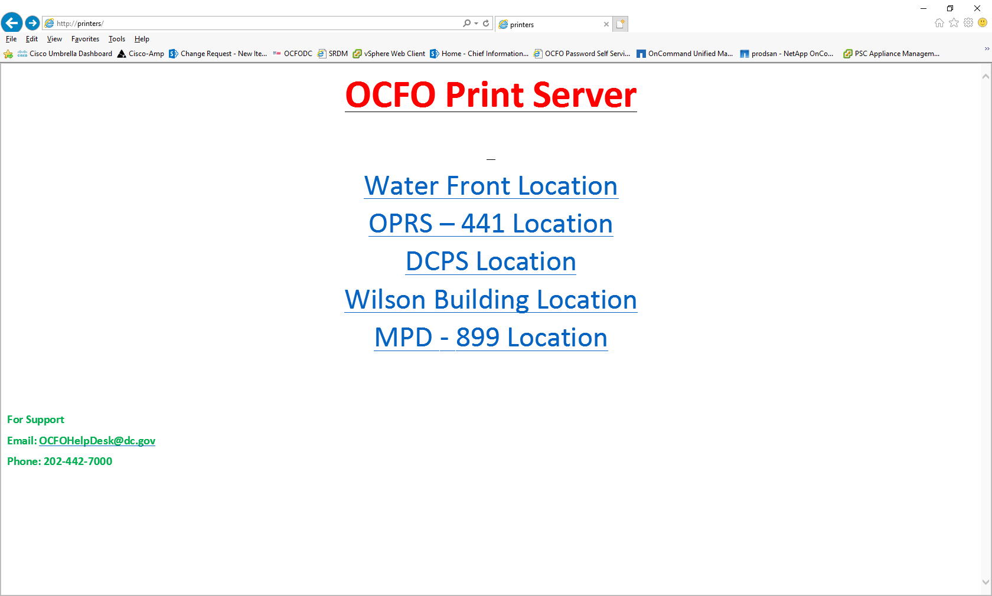

You will see list of all the printers at your location.
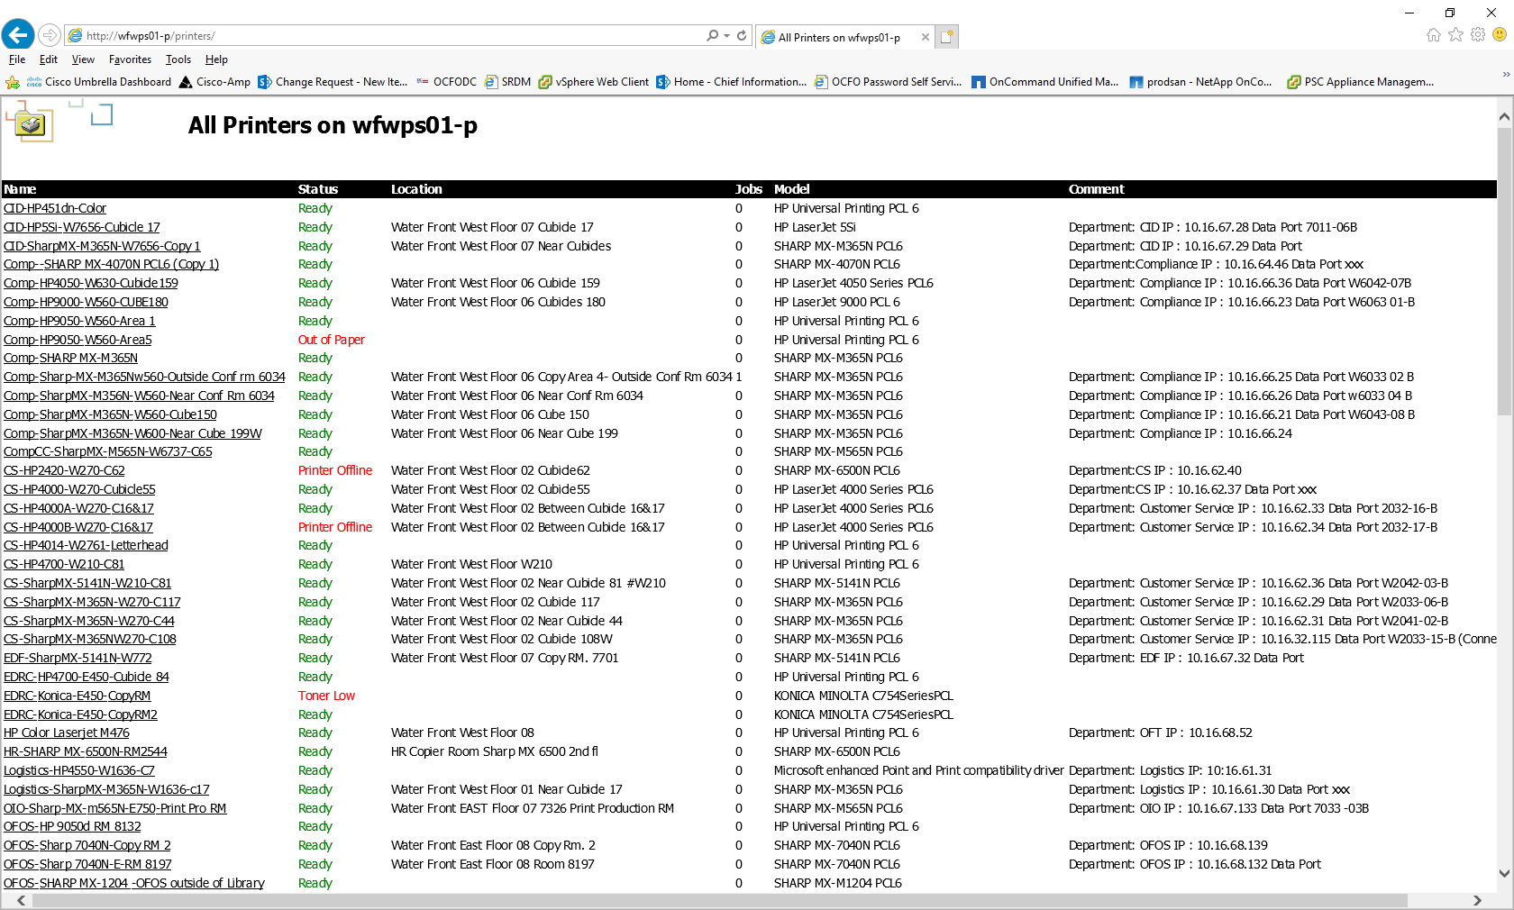

Find the printer you want to add and you may have to scroll down to find the printer. If you do not know the full name of the printer, you have to find the printer on the floor and get the name from the printer.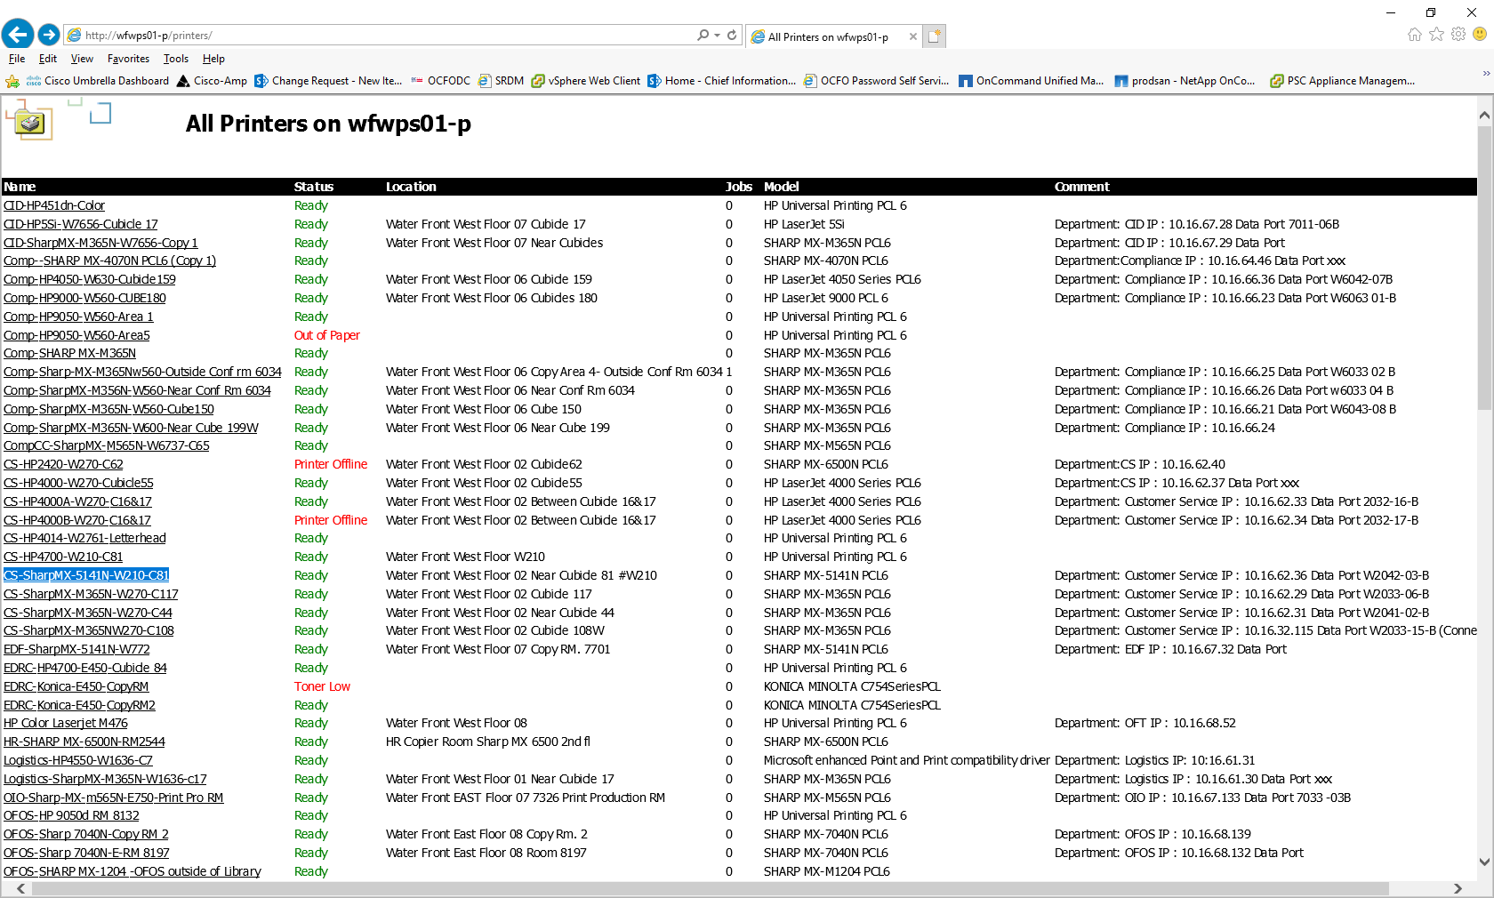
Click on the printer name and following page will appear. On the left side menu under Printer Actions, please click on connect. Once you click on connect, printer driver will be installed.
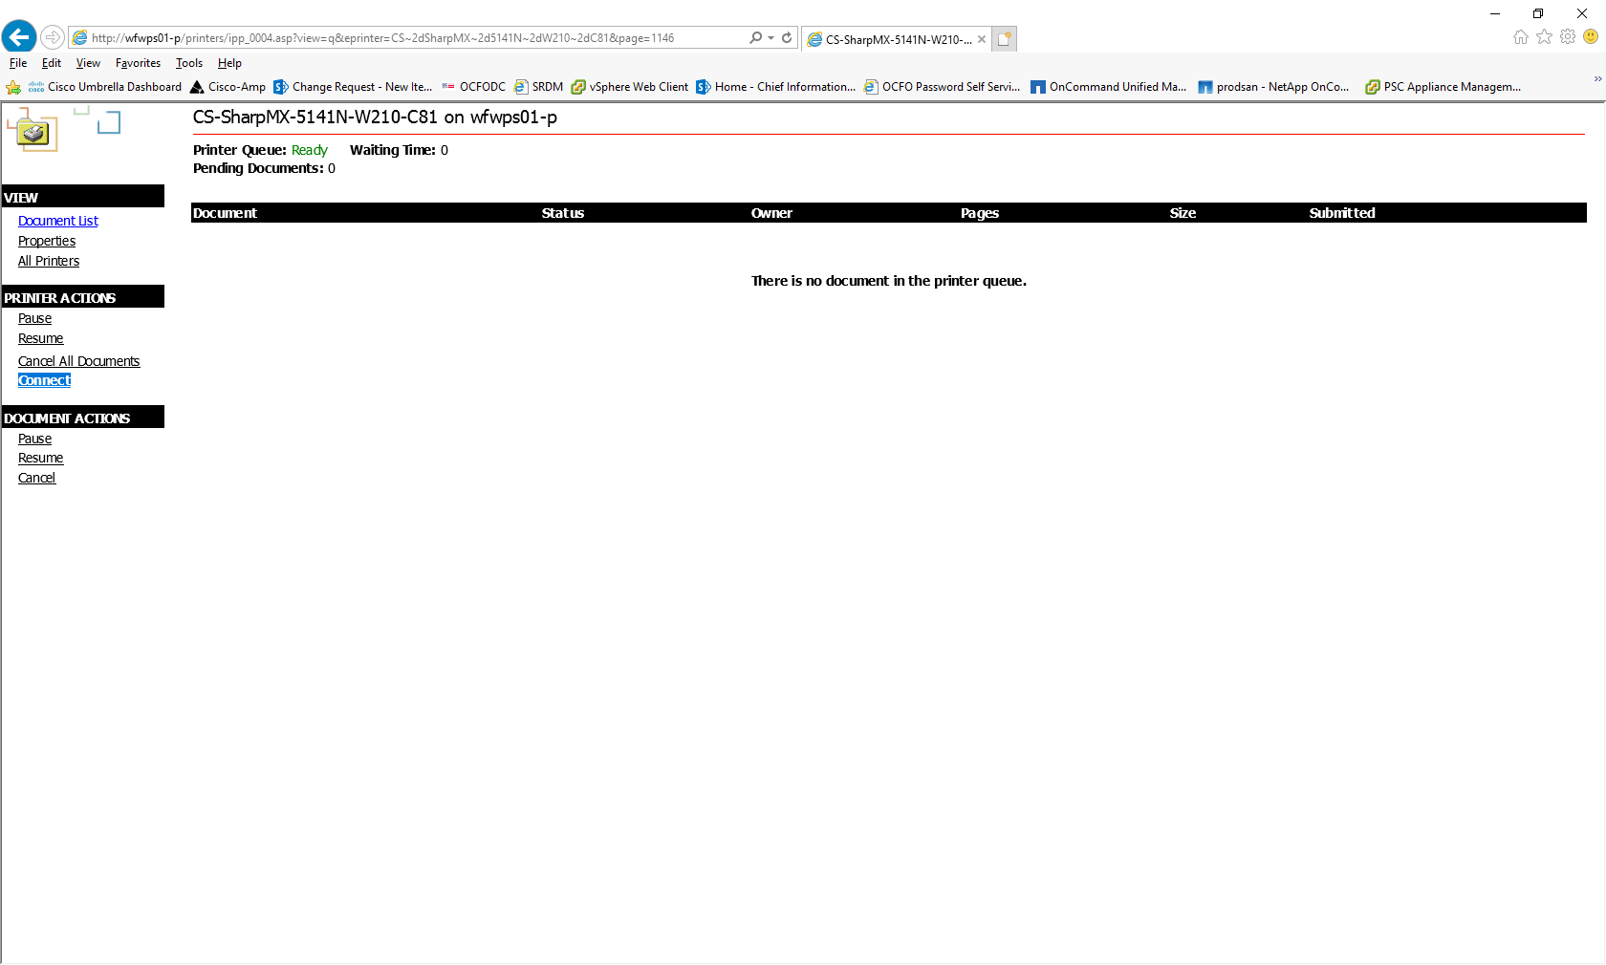

Click on ‘Yes’ on below window.
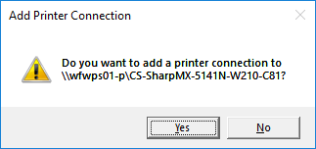

Once installation is complete, you will see the below window with message “The printer has been installed on your machine”. If you want to make this printer your default printer, click on “Click here to open the printer folder on your machine”. This link is below “The printer has been installed on your machine” message.

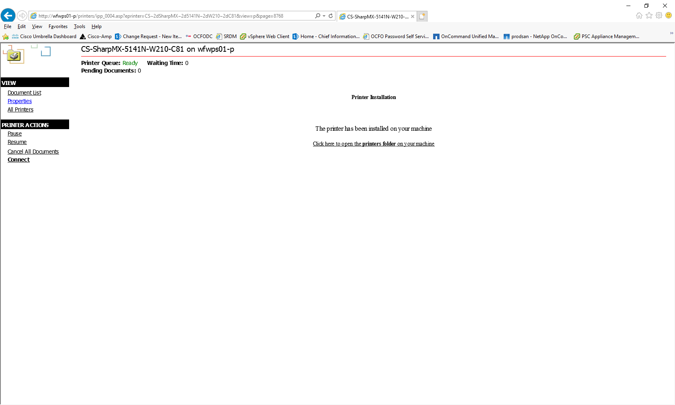

Right click on the printer you just configured and click on “Set as Default”.

